Online Blood Bank Management System

Use Case Document


 | Prepared By / Last Updated By | Reviewed by | Approved By
Name | Aaysha Begam A,  Lakshmi S R,  Manikandan J,  ManipriyaT,  Soundarya Lakshmi S | Aaysha Begam A,  Lakshmi S R, Manikandan J,  ManipriyaT,  Soundarya Lakshmi S | Poonkuzhali Anand
Role | Team Member | Team Member | Scrum Master
Signature | Aaysha Begam A,  Lakshmi S R,  Manikandan J,  Manipriya T,  Soundarya Lakshmi S | Aaysha Begam A,  Lakshmi S R,  Manikandan J,  Manipriya T,  Soundarya Lakshmi S | Poonkuzhali Anand
Date

Table of Contents
1.0 Introduction 3
1.1 Purpose & Scope of the document 3
1.2 Intended Audience 3
1.3 Use case ‘User Registration’ 3
1.3.1 Use case attributes 3
1.3.2 Use Case Model 4
1.3.3 Business Rules 4
1.3.4 UI Requirements 4
1.3.5 UI Field Validations 5
1.4 Use case ‘User Credential Authentication’ 6
1.4.1 Use case attributes 6
1.4.2 Use Case Model 7
1.4.3 Business Rules 7
1.4.4 UI Requirements 7
2.0 Database Design 8
2.1 Tables Structure 8
3.0 Change Log 10

Introduction

Purpose & Scope of the document
The purpose of this Use case document is to systematically capture requirements for the project and the system to be developed in terms of use cases. Functional use cases are captured in this document. It also serves as the input for the project scoping.

The scope of this document is limited to addressing the use cases from a user, quality, and non-functional perspective.

Intended Audience
Each member of the project team

Use case ‘User Login’

Use case attributes
Use Case Description:

This use case deals with the capture of user details. The User/Donor here shall be the operator of the system and will be keying in the online blood banking information into the system.

Scope:

- User/Donor registration

Actors:

- User/Donor – the operator

Trigger:

Click ‘Submit’ button in the ‘User /Donor Registration’ page

Pre-Condition:

The User/Donor being able to access the homepage & get redirected to the
User/Donor Registration’ page based on User/Donor upon click of ‘Register’ link.

Post Condition:

User/Donor is in the enrollment page & submit details

Flow of Events:

User/Donor at homepage → Click ‘Register’ link → User/Donor is in the enrollment page → User/Donor) details are submitted and added onto the database

Primary Scenario:
A new User/Donor – is able to click ‘Register’ link and able to provide his details and get enrolled in the system.

Use Case Model
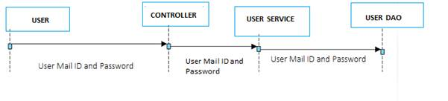

Business Rules

Business rules should be defined using the following attributes: -

- When the User/Donor clicks on the registration link, it should re-direct to registration form.
    - User needs to fill some of the basic attributes/fields as mentioned below in requirement: First Name, Last Name, Age, Gender, Contact Number, Email, Password, Blood group.
- Clicking ‘Submit’ should validate the datatype constraints for each field
- Post-successful field level validation, save the information in the database
- Upon saving the information in the database, display the message ‘Your details are submitted successfully’.

UI Requirements
Here is a prototype on how the homepage should look like.

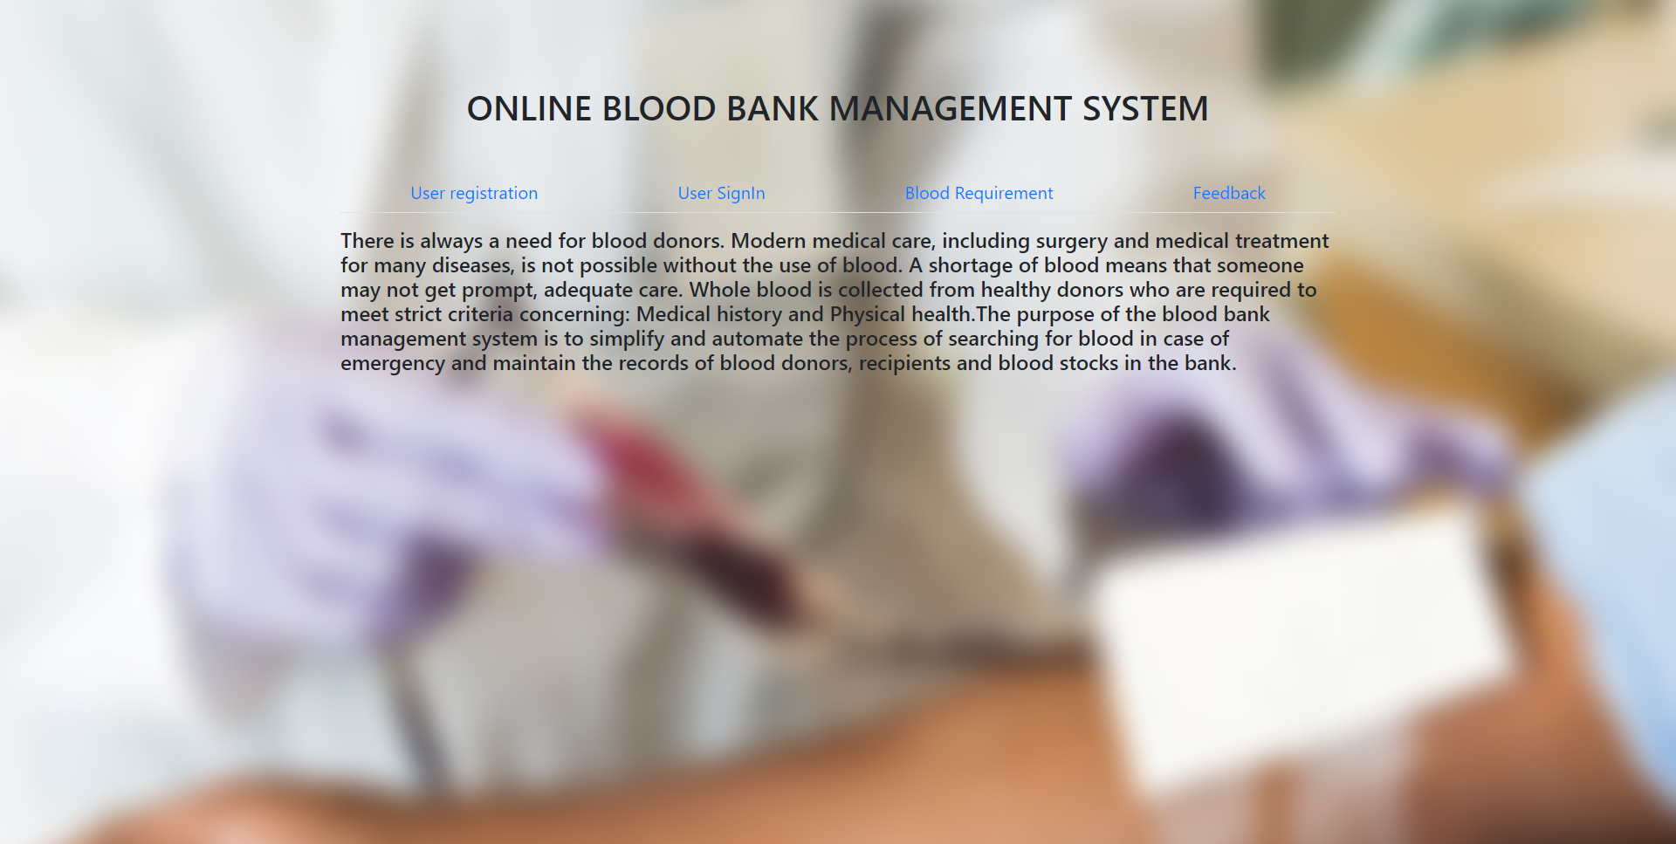

Here is a prototype on how the ‘User Registration’ page should look like.

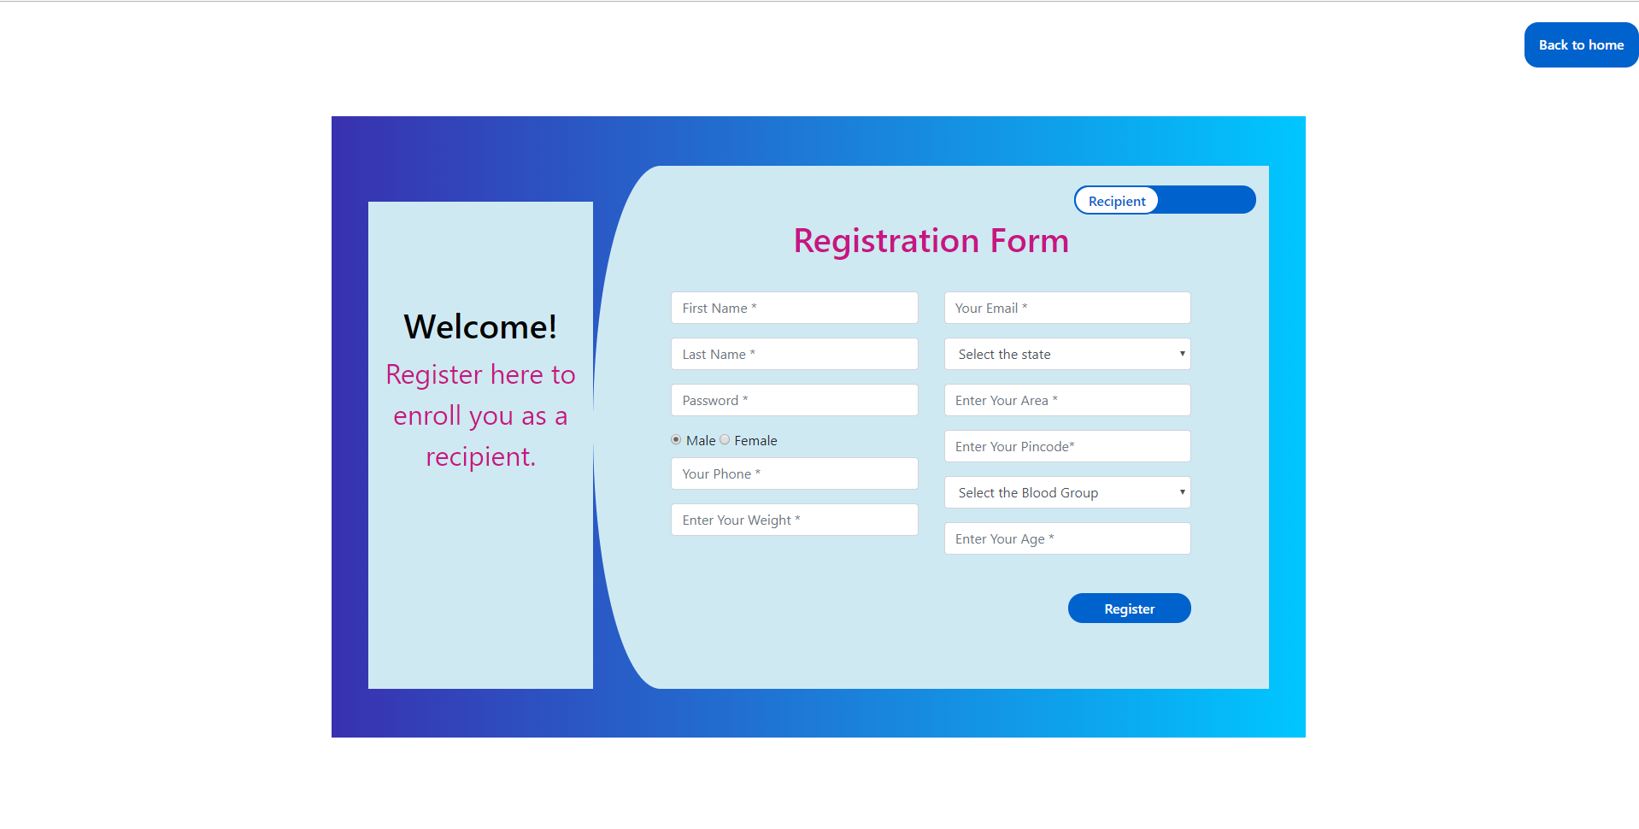

Here is a prototype on how the ‘User Login’ page should look like.

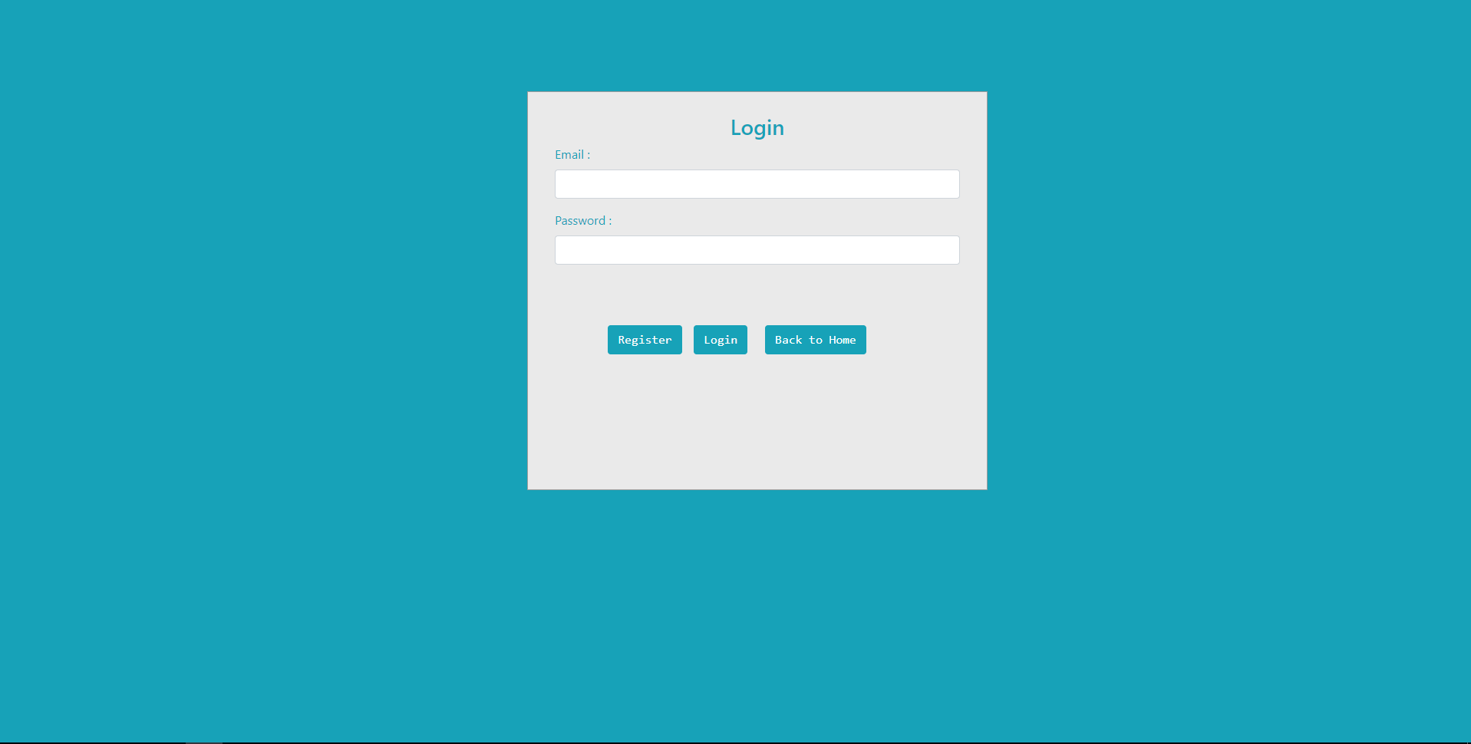

UI Field Validations
Please refer to the below requirements for field level validations:

- All fields are mandatory.
- Username should be less than 30 chars. Password should have minimum 8 chars, no space & can contain special characters (ex.!,@,#,%,*,& etc.)
- The Email ID format must be checked. (For ex. test@testmail.com.)
- Phone Number must be of 10 digits’ length

Use case ‘Donor Credential Authentication’

Use case attributes
Use Case Description:

This use case deals with the authentication of the Donor credentials. The ‘Donor’ here shall be the operator of the system and will be keying in the donor information into the system.

Scope:
- Donor credentials authentication

Actors:
Donor– the operator

Trigger:

Click ‘Login’ link, after keying in ‘User Name’ & ‘Password’ field.

Pre-Condition:

Donor being able to access the donor page.

Post Condition:

Donor is in the donor Registration page

Flow of Events:

User at homepage → Key in ‘‘User Name’ & ‘Password’ field → Donor credentials are validated → Donor Registration page is displayed.

Primary Scenario:
A registered user – is able click ‘Login’ link, after keying ‘User Name’ & ‘Password’ field and get his credentials authenticated with the existing database entry.

Alternative Scenario:
A registered user – is able click ‘Login’ link, after keying in ‘User Name’ & ‘Password’ field and unable to get his credentials authenticated. The user is presented with relevant error messages:

- Invalid User name – ‘The ‘User name’ provided does not exist in our records’
- Incorrect Password – ‘Password provided is incorrect. Please reach out to your system admin.’

Use Case Model
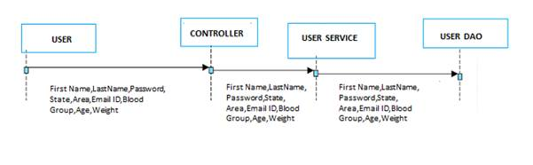

Business Rules
Business rules should be defined using the following attributes:-

- A registered user – is able click ‘Login’ link, after keying in ‘User name’ & ‘Password’ field and get his credentials authenticated with the existing database entry.

UI Requirements
Here is a prototype on how the Donor registration should look like.

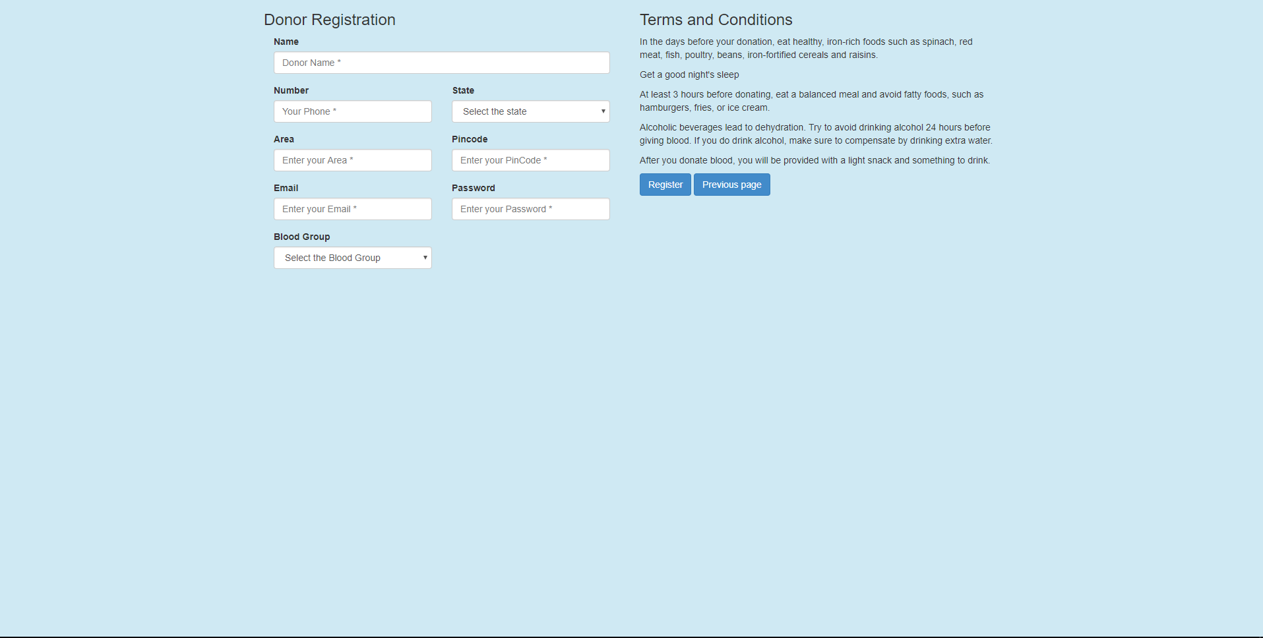

UI Field Validations
Please refer to the below requirements for field level validations:

- All fields are mandatory.
- Username should be less than 30 chars. Password should have minimum 8 chars, no space & can contain special characters (ex.!,@,#,%,*,& etc.)

- The Email ID format must be checked. (For ex. test@gmail.com.)
- Phone Number must be of 10 digits’ length.

Use case ‘User Credential Authentication’

Use case attributes

Use Case Description:

This use case deals with the authentication of the User credentials. The ‘Admin’ here shall be the operator of the system and will be keying in the Admin information into the system.

Scope:

- User credentials authentication

Actors:

User– the operator

Trigger:

Click ‘Login’ link, after keying in ‘User name’ & ‘Password’ field.

Pre-Condition:

User being able to access the homepage

Post Condition:

User is in the User Registration page

Flow of Events:

User at homepage → Key in ‘User name’ & ‘Password’ field → User credentials are validated → User Registration page is displayed

Primary Scenario:
A registered user – is able click ‘Login’ link, after keying ‘User name’ & ‘Password’ field and get his credentials authenticated with the existing database entry.

Alternative Scenario:
A registered user – is able click ‘Login’ link, after keying in ‘User name’ & ‘Password’ field and unable to get his credentials authenticated. The User is presented with relevant error messages:

- Invalid User name – ‘The ‘User name’ provided does not exist in our records’
- Incorrect Password – ‘Password provided is incorrect. Please reach out to your system admin.’

Use Case Model

Business Rules
Business rules should be defined using the following attributes:-

- A registered user – is able click ‘Login’ link, after keying in ‘User name’ & ‘Password’ field and get his credentials authenticated with the existing database entry.

UI Requirements
Here is a prototype on how the User registration should look like.

Database Design

Tables Structure

2.1.1 User (Recipient) Registration: 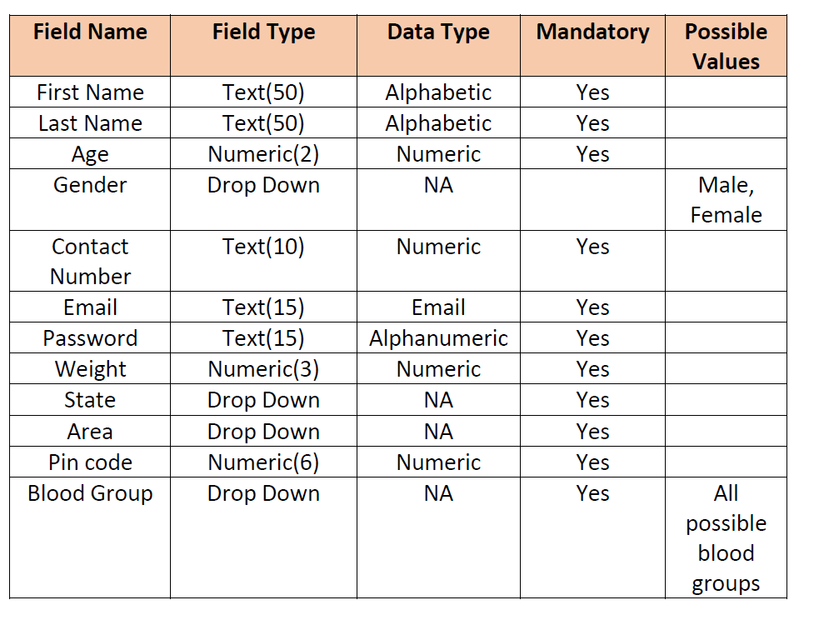

2.1.2 Search Donor:
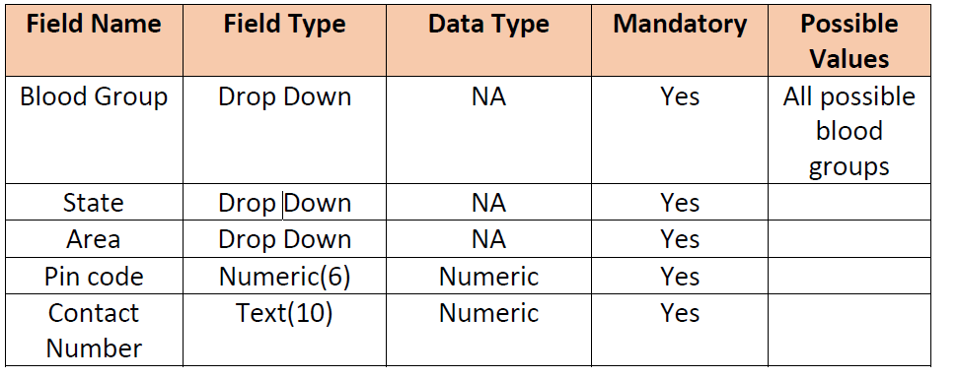

2.1.3 Donor Registration:

2.1.3 Hospital-Booking:
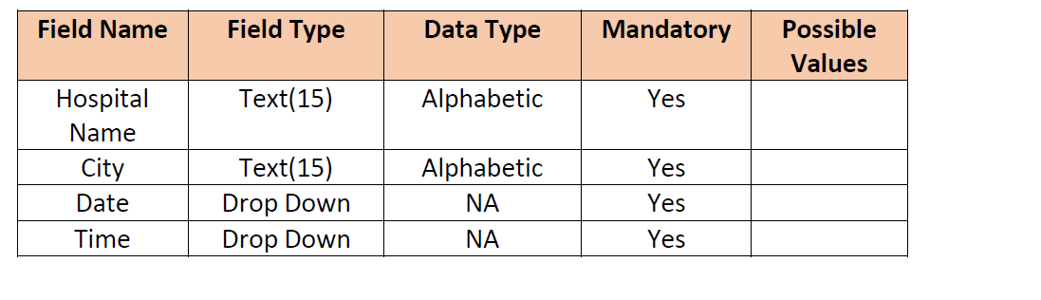

2.1.4 Feedback:
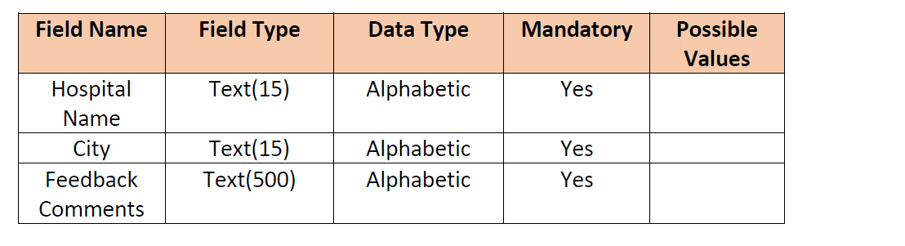

Change Log
Version Number | Changes Made
V1.0 | Initial baseline created on <dd-Mon-yy> by <Name of Author>
V1.1 | <Please refer the configuration control tool / change item status form if the details of changes are maintained separately. If not, the template given below needs to be followed>
V1.1 | Section No. | Changed By | Effective Date | Changes Effected

